**Low back pain with sciatica**

**Initial Assessment**

|  |  |  |
| --- | --- | --- |
| **Presenting Symptom/Chief Complaint** | | |
| Acute episode of low back pain with radiation to the legs due to cold and wind invasion. Pain is based of QI kidney deficiency with QI and blood stagnation at the area. | | |
| **Main Signs and Symptoms** | | |
| Patient is complaining of repeated acute episode of back pain with radiation to the legs. Straight sprain of the muscle and weaken kidney QI. | | |
| **Other Signs and Symptoms** | | |
| Otherwise, patient is healthy. | | |
| **TCM Diagnosis and Treatment (identified TCM disease, TCM differentiation of syndromes)** | | |
| Acute painful obstruction syndrome of the back area with pain dampness invasion and cold, and wind predisposition. Kidney QI deficiency (weakness) and QI stagnation. | | |
| **Treatment Principles and Strategies** | | |
| Expel wind, remove the cold and dampness, nourish kidney QI. Remove the muscle spasm and circulatory limitation. | | |
| **Treatment Plan (Modalities; acupuncture, herbal, dietary, manual therapies), frequency and duration** | | |
| Acupuncture 2-3 times a week with starting of local joints primary to distal. Till the symptoms resolved. Acupuncture **SJ3 (L) 1 ST** + UB 6(R) 2nd -opening the governing vessel. | | |
| **Any other Advice Given to Patients** | | |
| UB 60, KI 4-tonification of kidney QI. SP 6, DU 20-effect the governing vessel. H7(R) calming mindand relaxing the spasm muscles. Combination of source and back - shu points at the area and for the main channels involved. SP 3-UB 20(bilaterally) for muscle spasm (SP). K3-UB23 (bilaterally) -back pain (KI channels). UB 11-GB 39(bilaterally) cartilage involvement (LI), distal pain for sciatica (full condition due to damp -cold)). UB 40(for acute period only), UB 60, UB 62(hip), K4 with combination UB58(thigh). | | |
| **Practitioner:** | **Date:** | **Signature:** |

**Low back pain with sciatica**

**Dally Charting____________________________________Patient Name:_**

**Date:_**

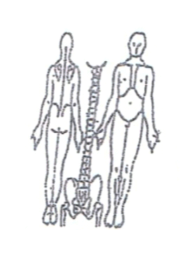Working Diagnosis:Acute painful obstruction syndrome at the back area with main cold-wind dampness invasion and KI QI depletion and stagnation.

S: Patient is complaining of the episode of acute back pain with strong restriction to movement and radiation of the pain along the side and back to the legs. Syndrome is severe and interfering with daily living function and sleep.

O:

Treatment (P) UB 60, KI 4-tonification of kidney QI. SP 6, DU 20-effect the governing vessel. H7(R) calming mindand relaxing the spasm muscles. Combination of source and back - shu points at the area and for the main channels involved. SP 3-UB 20(bilaterally) for muscle spasm (SP). K3-UB23 (bilaterally) -back pain (KI channels). UB 11-GB 39(bilaterally) cartilage involvement (LI), distal pain for sciatica (full condition due to damp -cold)). UB 40(for acute period only), UB 60, UB 62(hip), K4 with combination UB58(thigh).

**(A)** Acupuncture + Moxibustion 1 hour as per plan.

**Date:_ _______________**

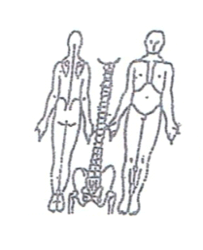**Working Diagnosis:**

S: Pain is still the same. 5-6 on the pain scale of 1-10. Severe limitation to the

movement pain with walking or changing position in the bed.

O:

Treatment (P) Acupuncture with strong needle stimulation of the distal points for 10-

15 minutes following by tonification of the local points for 45-50 minutes.

(A)

**Date: April 30,2015**

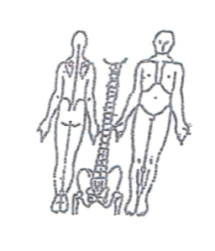**Working Diagnosis:**

S: Pain is still the same. Better movement with back support belt. Better sleep. Daily

activity is very limited due to pain.

O:

Treatment (P) Acupuncture with Moxibustion. 1 hour needling of back - shu points of

the main channels involved.

(A)

**Date: May 02, 2015**

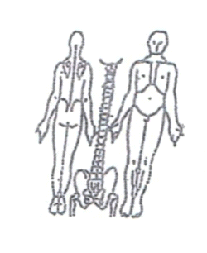**Working Diagnosis:**

S: Pain is still severe, with slight decrease of intensity. Radiation of pain to the legs.

ROM. (ST) Movement with back belt support.

O:

Treatment (P) Acupuncture with sedation of the distal joints following by tonification of

the local joints for 1 hour.

(A)

**Dally Charting____________________________________Patient Name:**

**Date:_ May 05, 2015**

**Working Diagnosis:**

S: Pain ↓; For the first time patient sleeps N and wake up energized in the morning. ROM ↑. Still using back support belt, but pain is ↓

O:

Treatment (P) Acupuncture with sedation of peripheral needles.

(A)

**Date:_ May 07, 2015**

**Working Diagnosis:**

S: Pain ↓ ; patient sleeps N and wake up energized in the morning. ROM ↑. Still using back support belt, but pain is↓

O:

Treatment (P) Acupuncture with sedation of peripheral needles.

(A)

**Date:_May 09, 2015_______________**

 **Working Diagnosis:**

S: Pain . Patient sleeping much better. level of energy, ROM feeling more energized and less pain with movement. Still using the back support belt during the day.

O:

Treatment (P) Acupuncture + Moxibustion 1 hour according to the treatment plan.

(A)

**Date: May 12, 2015**

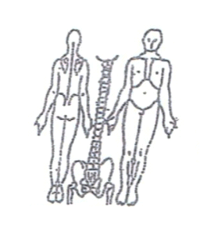**Working Diagnosis:**

S: Pain is . ROM; daily movement. N sleep. level of energy. movement. No back belt support used.

O:

Treatment (P) Acupuncture + Moxibustion. Imunno stimulating and analgetic

protocol 1 hour used.

(A)

**Date: May 14, 2015_______________**

**Working Diagnosis:**

S: Patient is feeling well. No pain at the back area. N ROM. N sleep. No limitation of

daily living, started remedial exercises.

O:

Treatment (P) Acupuncture + Moxibustion 1 hour according to the protocol.

(A)